**Saint Brigid Saint John the Baptist**

20h Sunday in

Ordinary Time

August 19, 2018

**Catholic Church Catholic Church**

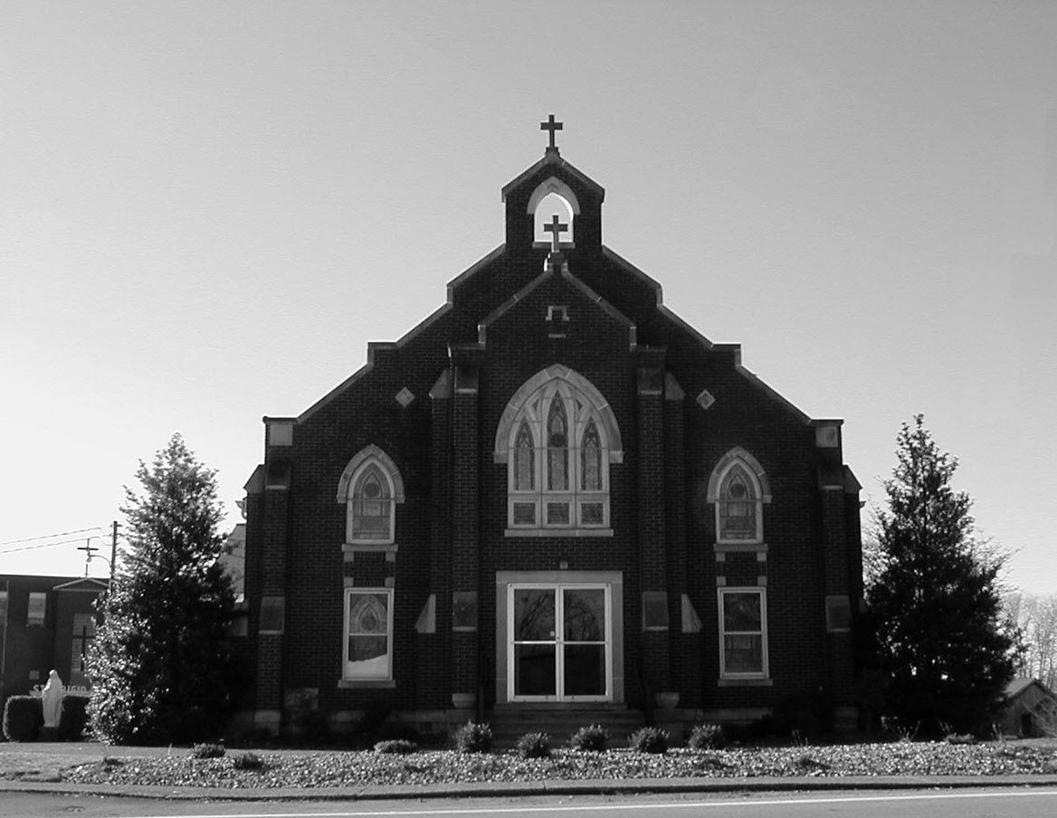

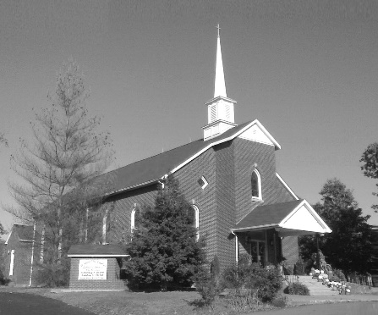

**Pastor:**

***Rev. Daniel L. Lincoln***

Rectory: (270) 877-2546

**Deacon:**

***Michael A. Ryan***

(270) 272-6789

314 E. Main St. 657 St. John Church Rd.

Vine Grove, KY 40175 Elizabethtown, KY 42701

Clustered Parish Office: Clustered Parish Office:

(270) 877-2461 (270) 877-2461

**ANNOINTING OF THE SICK:**

Notify the parish office when a family member is hospitalized.

**BAPTISM:**

Contact the parish office for information about the required preparation class.

**BULLETIN:**

Information must be submitted in writing by note or email to the parish office **no later than 12:00 noon on Wednesdays** for the following weekend. When sending an email, please put “BULLETIN,” and the name of the parish the announcement is for, in the subject line.

**MARRIAGE:**

Contact Father at least 6 months prior to the wedding date to complete required marriage preparations and to schedule the date.

**RCIA (Rite of Christian Initiation of Adults):**

Contact the Worship Chairperson for information.

**DEW MEMORIAL LIBRARY:**

(in St. Brigid Church basement):

Open: Sunday after 9:30 a.m. Mass& 45 minutes before all other Masses.

Email: [brigidvg@bbtel.com](mailto:brigidvg@bbtel.com) **Dir. of Religious Education:**

Website: [www.stbrigidvg.org](http://www.stbrigidvg.org)Lisa Thomas: (270) 735-6930

**Pastoral Associate & Dir. Youth Ministers:**

**of Religious Education:** Angela Churchman:

Deacon Mike Ryan: (270) 877-0546 (270) 268-9963

**Youth Minister:** Ericka Finlay: (502) 612-2644

Lori Law: (270) 723-0157

**MASS SCHEDULE:**

*Saturday (Vigil):*  6:30 p.m.

*Sunday:* 11:30 a.m.

*Wednesday:* 6:30 p.m.

*Friday:* 9:00 a.m.

**RECONCILIATION:**

Saturday before Mass

5:30-6:00p.m. or by appt.

**PARISH COUNCIL MEMBERS:**

*President:* Lauran Thomas

*Secretary:* Theresa Smith

**CHAIRPERSONS:**

*Administration:*  Nick Thomas

*Formation:* Ericka Finlay

*Parish Life:* Bradley Wickersham

*Worship:* Greg Thompson



**MASS SCHEDULE:**

*Sunday:* 9:30 a.m. & 6:30 p.m.

*Monday:* 9:00 a.m.

*Thursday:* 9:00 a.m.

**RECONCILIATION:**

Sunday before Mass

5:30-6:00 p.m. or by appt.

**ROSARY:**

After weekday Masses

**PARISH COUNCIL MEMBERS:**

*President:* Sue Weisshaupt

*Vice-President:* Mike Bramlett

*Secretary:* Judy Cochran

*At-Large Members:* Blake Ryan

& Vincent Thompson

**CHAIRPERSONS:**

*Administration:* Dale Winchester

*Formation:* Tina Yates

*Parish Life:* Tom Billings

*Worship:* Keith Baughman

**Mass Schedule**

**Mass Schedule**

|  |  |  |  |  |  |
| --- | --- | --- | --- | --- | --- |
| **Saturday** | **August 18** | **6:30 p.m.** | **St. John** | **For All Parishioners** | **Vigil: 20th Sunday in Ordinary Time** |
| **Sunday** | **August 19** | **9:30 a.m.** | **St. Brigid** | **Inge Luther, Cameron Ponder**  **& Luise Weisshaupt** | **20th Sunday in Ordinary Time** |
| **“** | **“** | **11:30 a.m.** | **St. John** | **Kenneth Wiseman** | **“** |
| **“** | **“** | **6:30 p.m.** | **St. Brigid** | **Our Parish Family**  **Mike Mullarkey** | **“** |
| **Monday** | **August 20** | **9:00 a.m.** | **St. Brigid** | **Dickie Cecil**  **Richard Hughes** | **Weekday** |
| **Wednesday** | **August 22** | **6:30 p.m.** | **St. John** | **Bruce & Margaret Lincoln** |  |
| **Thursday** | **August 23** | **9:00 a.m.** | **St. Brigid** | **Carlos Robbins**  **Helen Adams** | **Weekday** |
| **Friday** | **August 24** | **9:00 a.m.** | **St. John** | **Fr. Stan Osborne** | **Weekday** |
| **Saturday** | **August 25** | **6:30 p.m.** | **St. John** | **Anna Brangers** |  |
| **Sunday** | **August 27** | **9:30 a.m.** | **St. Brigid** | **Mack, Leanna & Billy Cecil** |  |
| **“** | **“** | **11:30 a.m.** | **St. John** | **For All Parishioners** | **“** |
| **“** | “ | **6:30 p.m.** | **St. Brigid** | **Our Parish Family**  **Buckman Family & Erik Whelan** | **“** |

**INFORMATION FOR BOTH PARISHES**

**PRAYERS** – For all students, teachers and families at the beginning of this school year, that it may be a grace-filled time of learning and wisdom.

**GUIDE BOOK & DIRECTORY ADVERTISING OPPORTUNITY** – We are in the process of updating our annual Guide Book & Directory for our churches. This book will contain everything pertinent to our church: the various ministries, organizations, committees, activities, functions and events plus a complete directory of all members. This book is being provided and direct-mailed to each family at no cost to our church, and it is again being subsidized by local businesses that advertise. If you own or manage a business and would like to find out about advertising in our book, please call the Church Office. Recent survey results by Guide Book Publishing show that 92.1% of families would rather patronize a Guide Book & Directory advertiser over a non-advertiser. It “will pay” to advertise in our new Guide Book & Directory.

**ABORTION AND ADOPTION –** The number of would-be adoptive parents (of newborn babies) far outstrips the supply in America. Each year in the United States, about 135,000 American children are placed for adoption. Experts estimate somewhere between one and two million couples seek to adopt yearly. Every year, there are about 1.3 million abortions. Sadly, only 4% of women with unwanted pregnancies give their children up for adoption. Every child is wanted and wanted desperately! By Pro-Life Articles Author [www.pro-lifearticles.org](http://www.pro-lifearticles.org)

**PROJECT RACHEL** **–** Healing…Forgiveness…Hope…After the experience of an abortion. If you or someone you know is struggling with the pain from an abortion, please consider Project Rachel – a post abortion ministry. To speak to someone confidentially, call (502) 471-2155 or email [ProjectRachel@archlou.org](mailto:ProjectRachel@archlou.org).

**CONFIDENTIAL PREGNANCY AND ADOPTION COUNSELING** – is available at Catholic Charities for women of all ages experiencing untimely pregnancies. A full range of services are provided, including adoptive placement, legal assistance and counseling for individuals, groups and families. Post-abortion counseling is also available. Services are provided regardless of income or marital status. For more information, call Catholic Charities at (502) 637-9786.

**A LINCOLN TRAIL GOLF COURSE BUFFET** – will be held from 11:00 a.m. to 2:00 p.m. the first Sunday of every month. For more information, contact Patty Straney at (270) 268-3336.

**5TH ANNUAL ST. MARTIN OF TOURS PARISH PICNIC (FLAHERTY)** – Featuring live music by *Underground Experience*. Our meal comes with (pork, chicken), sides and homemade desserts. There will be a car show, live auction, bouncy houses, games and face painting for the kids. **Date: Saturday, September 8 from 2:00-10:00 p.m.**

**St. John and St. Brigid Prayer List**

To add someone to the prayer list, please call the parish office at (270) 877-2461. **Remember to call to remove someone from the list if they are no longer sick, etc.** *Please note that the prayer list has been revised. It is primarily for parishioners and their immediate family members*.

Leslie **Adams-Cerniglia**, Sam **Adams**, April **Allen**, Dennis **Arnold**, Barbara **Ashley**, Donnie Alan **Atcher**, Sue **Banks**, Shannon **Barnes,** Denise **Barnett**, Timothy **Birch**, Teresa **Blaycock**, Charlie **Bowers**, Pauline **Brangers**, Ellen **Bryan**, Richard **Bryson**, Carol **Buchanan**, Linda **Buchanan**, Jeremy & Margie **Buyer**, Deacon Bob **Caspar**, Sue **Caswell**, Ed **Cecil**, J. Mack **Cecil**, Harlan Ford **Clark**, Judy **Cleaver**, John **Connor**, Betty Jo **Cooper**, Heidi **Correa**, Jeff **Craig**, Glynn **Clutches**, Roan **Dowell**, Karen **Dworshak**, Leroy **Embry**, Marion **French**, Martha **Ford**, Dwayne **Garcia**, Carrie **Gribben**, Mary **Hager**, Mrs. Charles **Hair**, Stephanie **Hall**, Donnie **Hart**, Jimmy **Harper**, Bobby **Harris**, Eileen **Heinen**, Debbie **Hodge**, Betty Lou **Jones**, Charlene **Langley**, Olivia **Leasor**, Jenny **Leonhardt**, Jackie **Long**, Louise **Lucous**, Alma **Mahanna**, Shelly **Martin**, Shirley **Martin**, Martina **Masoni**, Don **Mattingly**, Gerard **Mattingly**, Paul Michael **Mattingly**, Mary **Medley,** Cindy **Miller**, Starla **Miller**, Doug **Osborne**, Duane **Osborne**, Mickey **Padgett**, Frank **Inanely**, Jerry **Phillips**, Annie **Pierce**, Adrianna **Porter**, Jeremy **Porter**, Adrian **Ray**, Allie **Ray**, Mary Agnes **Ray**, Mary Ellen **Ray**, Tonya **Reisinger**, Joel **Rivera**, Pat **Ryan**, Caroline **Seabee**, Leon **Skeeters**, Jim **Smith**, Ralph **Staples**, Keith **Tassin**, Kenny **Thompson**, Raffaella **Tucker**, Debi **Turner**, Stacey **Vance**, Charlotte **Vowels**, Bill **Waldrop**, Lois **Weaver**, De Neil **Whelan**, Paul A. **Whelan**, Jennifer **Williams**, Sandy **Wiseman**, Zach **Wiseman**, Gail **Wilson**, Don **Wooldridge**, Connor **Wright**, and all the sick.

* * * * * * * * * * * * * * * * * * *

**Our Military List**

To add someone to the military list, please call the parish office at (270) 877-2461. **Remember to call to remove someone from the list if they are no longer in the service**.

Lt. Matt **Bednar**, PFC Richard H. **Chapman**, A1C Aaron **Chandler**, A1C Brandon **Davila**, SrA Felicia **Esquivel**, PFC Tyler **Hall**, A1C Ryan **Henley**, A1C Joseph **Manco**, SPC Jacob L. **Nall**, SFC Peter **Novak**, Tony **Rickerl**, James **Rogers**, Tony **Rogers**, Jonathon **Sifford**, Jeffrey **Slade**, Derek **Smith**, CSM Vance **Snider**, Brian **Tomassi**, A1C Daniel **Trombone**, SGT Evan **Vaughan**, PV2 William **Vaughan**, Lisa **Flynn-Veri**, LT Michael **Veri**, LTC Steve **Wickersham**, SGT Clay **Wilson**, TSGT Jeremy **Yates**, Austin **Zulka** and for all who serve and have served our country.

* * * * * * * * * * * * * * * * * * *

**ST. JOHN THE BAPTIST CATHOLIC CHURCH INFORMATION**

**Monthly Budget Amount Needed:** $ 12,500.00

**Monthly Collection for July:** $ 14,040.00

**Monthly Collection for August:**  $ 6,829.50

**WELCOME PACKETS** – If you would like to become a member, or learn more about St. John Parish, please take a *Welcome Packet* in the church lobby. You may return the census card and the stewardship form to Father Dan or place in the collection basket.

**UPDATE MEMBERSHIP INFORMATION** – Does our church database have YOUR family membership record correct? Here is your chance to update YOUR record for our annual Guide Book & Directory (if you haven’t already done so). It is time for us to update our database with any changes, additions, or deletions that may have occurred in YOUR family over the past year. Have you changed your phone number? Have you moved? Are you preparing to move soon? Are all of your children still at home and are they all included in your membership record? Do you want your record published? If you have not already informed the Church Office about changes to your record, please let us know now so that the information in the Guide Book & Directory is correct. The Church Office number is (270) 877-2461. *Thank you for your help!*

**ST. JOHN COOKBOOK** – Looking for someone that would take the lead on putting together all the yummy recipes from the great cooks of St John. If you are interested in helping with this project, please contact Martha Thomas at (270) 765-9660 or [mthomasemail@windstream.net](mailto:mthomasemail@windstream.net) or Clarissa Yates at (270) 862-3792 or [cpyates@comcast.net](mailto:cpyates@comcast.net).

**DISCERNMENT CORE TEAM UPDATE –** We are continuing to work on implementing many of the suggestions that were discussed in the small group gatherings.  Our Facebook page is up and running thanks to Kolbe Disselkamp and Dana Ingram.  Hannah Thomas is working on a web page for the Church.  Our hope is that these two items alone will help to keep everyone more informed about happenings in our parish.  As of the first of August all stewardship lists have been updated and are in place.  If you haven't completed a stewardship form they are still available, ask Father or one of the Core Team members.  If you don't see your name appear over the next few months in one of the Mass roles that you wanted to participate in, please reach out to the Core Team and we will make sure that your information is updated.  Over the next several months we will be coordinating meetings for all new committees so that everyone has a chance to participate.  Some committees may only meet once or twice a year, but please try to attend these meetings so that your gifts of time, talent and treasure can be shared with our parish.  Any questions can be directed to one of the Core Team Members:  Clarissa Yates, Rick Newton, Rhonda Newton, Karen Ray, Ericka Finley, Lisa Thomas

**RELIGIOUS EDUCATION –**RE classes will begin on **Sunday, September 9,** **from 9:45 to 11:00 a.m.** Please contact Lisa Thomas (270) 735-6930 or [glalt@comcast.net](mailto:glalt@comcast.net) with any questions you may have.

**PETER’S PENCE** – This annual door collection will be this weekend **August 18-19**.

**SERVER TRAINING** – Where: St. John the Baptist Catholic Church. When: after the 11:300 Mass on **August 19.** You must be 4th grade; you can be 3rd grade with approval from Father Dan. Regardless of grade you must have completed sacraments of First Communion and First Penance. I am looking especially for servers for Saturday nights. If you are an existing server, please attend. There are a few things different we all need to be in the same step on.

**PARISH COUNCIL** – will meet on **Monday, August 20, at 6:30 p.m.** in the Parish Hall.

**SAFE ENVIRONMENT TRAINING –** Anyone 18 and older, volunteering in our parish with the RE program, Youth Group, VBS, etc. must attend a Safe Environment Training Seminar sponsored by the Archdiocese.  These are scheduled at various times throughout the Archdiocese. The complete list of available dates can be accessed on the Archdiocese website.  The next scheduled training in our area will be **Thursday,** **August 23, at 6:30 p.m. at St. James Church, Batcheldor Hall in Elizabethtown.** Any questions regarding this training please contact Lisa Thomas  (270) 735-6930 or [glalt@comcast.net](mailto:glalt@comcast.net).  If you attend this training, please be sure to return your completed form to Lisa Thomas.

**PARISH PICNIC –** Mark your calendars now for our Parish Pic-Nic to be held **Sunday, September 23, following the 11:30 a.m. Mass.**  A planning meeting for this event is scheduled for **Wednesday, August 29, at 6:45 p.m.**  Anyone interested in helping with this event please attend this planning meeting.

* * * * * * * * * * * * * * * * * * *

**St. John Liturgical Ministers**

|  |  |
| --- | --- |
| **Vigil: 21st Sunday in Ordinary Time, August 25, 2018, 6:30 p.m.** |  |
| Extraordinary Ministers of the Eucharist | Joanna Sherrard Lori Shinault Amy Thomas |
| Lector | Tony Smith |
| Servers | Claire Thomas Audrey Hunt |
| Greeter(s) | Angela Churchman |
| Gift Bearers | Leann & Chris Davidson |
| - Ushers | Mark Geer Kenny Thompson |
| **21st Sunday in Ordinary Time, August 26, 2018, 11:30 a.m.** |  |
| Extraordinary Ministers of the Eucharist | Jennifer Updegraff Lauran Thomas Amy Thomas |
| Lector | Joe Vititoe |
| Servers | Olivia Leasor Rilee Leasor |
| Greeter(s) | Darlene Pawley |
| Gift Bearers | Roger Ovensen Family |
| Ushers | Steve Brangers Nick Thomas |
| **Hospital Ministry – Sunday, July 22, 2018** | Marcella Brangers |

**ST. BRIGID CATHOLIC CHURCH NFORMATION**

**Monthly Budget Amount Needed:** $ 25,280.00

**Monthly Collection for July:** $ 34,424.15

**Monthly Collection for August:** $ 14,526.00

**WELCOME VISITORS** – If you are interested in joining our parish, please pick up a Welcome Packet at the church doors. Complete the registration form and either drop it in the collection basket or mail it to the office. If you just need to update your registration, there are also forms available.

**A HUGE THANK YOU** – to Dale Winchester and George Wiseman for the great paint job and work in the Parish Office. God bless you for your service to our parish.

**THANK YOU** – to Mary Katherine Winchester for the landscaping in front of church and to Bob and Deedie Cooper for the landscaping in front of the rectory. It all looks great!

**SPECIAL THANKS** – Thank you to Blake Ryan for doing the cat 5 wire ends in the main office. Good job.

**UPDATE MEMBERSHIP INFORMATION** – Does our church database have YOUR family membership record correct? Here is your chance to update YOUR record for our annual Guide Book & Directory (if you haven’t already done so). It is time for us to update our database with any changes, additions, or deletions that may have occurred in YOUR family over the past year. Have you changed your phone number? Have you moved? Are you preparing to move soon? Are all of your children still at home and are they all included in your membership record? Do you want your record published? If you have not already informed the Church Office about changes to your record, please let us know now so that the information in the Guide Book & Directory is correct. The Church Office number is (270) 877-2461. *Thank you for your help!*

**BASKETBALL PROGRAM** – Basketball will not begin until October, so we will post sign-up sheets in August. So far, we have had one adult offer to coach and one adult offer to coach and play in an adult league.

**EXTRAORDINARY MINISTERS OF THE EUCHARIST RECRUITMENT** – Extraordinary Ministers are members of the parish community who volunteer to assist the Clergy in the distribution of the Holy Eucharist at Mass. If you would like to be part of this very rewarding ministry please provide your name, telephone number, and mass preference to Sherleen Barren, (270) 877-5850 or barrenr@bbtel.com.

**RELIGIOUS EDUCATION NUMBERS** –

Preschool – 3 Grade 5 – 2

Kindergarten – 0 Grade 6 – 0

Grade 1 – 1 Grade 7/8 – 2

Grade 2 – 0 Grade 9/10 – 4

Grade 3 – 3 Grade 11/12 – 1

Grade  4 – 3 **TOTAL  19**

**HELP** – St. Brigid is in great need of volunteers to serve as Hospital Ministers to take communion to those who are ill. We are down to only two sets of volunteers! If you would like to assist in this ministry, call either Keith Baughman at (270) 877-5283 or the Parish Office.

**PETER’S PENCE** – This annual second collection will be taken after Communion next **Sunday,** **August 19**.

**PARISH COUNCIL** – will meet on **Thursday, August 23, at 7:00 p.m.**

**RELIGIOUS EDCATION** **– starts Sunday, August 26, at 10:30 a.m.** Please register your children for this awesome adventureabout our Catholic Faith. We will provide the education - it is your job to provide the children to include teens. Any questions contact Deacon Mike.

**SUMMER EVENT** – The Summer Event is fast approaching, **Sunday, September 16 from 1:00-4:00 p.m.**  THIS IS OUR ONLY FUND RAISER FOR ST. BRIGID AND WE NEED ALL TO PARTICIPATE TO MAKE IT A GREAT SUCCESS. It provides for many renovation projects.  We are selling 300 tickets to win a $10,000 Capital Prize.  The odds are tremendous and has been won by a parishioner every year.  The tickets are $100 each, but you can split the cost with a group.  Two dinner tickets come with each ticket purchased.   We'll have Silent Auction items, live music, bounce houses, and other activities for kids of all ages.  The Summer Event Ticket Order Forms are at the side doors of the church and the table in the back of church.  A committee member will be available after each Mass to assist in your purchase.  We also need volunteers to help.  **GET INVOLVED!** Should anyone need additional information, please contact Teresa Morgan (270) 862-2909; Gina Ryan (270) 735-6355 or Deacon Mike Ryan (270) 877-0546 or (270) 272-6789.

**SILENT AUCTION** – The sign-up sheet for silent auction baskets is in the baskets in the rear of church. Please take a basket and fill it up for our Summer Event Silent Auction. **Due to the new Kentucky tax laws we will have to charge 6% sales tax on all final bids and collect the money at the end of the auction.** Any questions or concerns can be addressed with Deacon Mike.

**SUMMER EVENT TICKET SALES** – We have sold 104 tickets so far. We have 196 tickets left. We have 29 days until September 16, 2018 Summer Event. We need to sell 6.75 tickets per day to sell all the summer event tickets. **(This does not include any Terri has sold.)**

**QUILT RAFFLE** –This year’s quilt is a blue flower pattern. The quilt is on display at the main doors of the church. We have quilt tickets for sale at $1.00 each.

**COMMUNION MINISTER UPDATE SESSIONS** – **September 27, 2018, Thursday, 7:00–9:00 p.m. Location: St. Brigid Church.** The sessions are for those ministers needing a mandate renewal, who have already completed the archdiocesan two-session Communion Minister Formation Program. This session will fulfill the requirements for continuing formation for Extraordinary Ministers of Holy Communion. Please add to your calendar. I will put the form applications out three weeks before and make sure a new announcement gets into the bulletin. **There is no fee for EMHC formation, but registration is required. Funded by the Catholic Services Appeal. Please register by one of the following methods:**

* **Internet:** [**https://www.archlou.org/services-directory/archdiocesan-agencies-facilities/worship-office/**](https://www.archlou.org/services-directory/archdiocesan-agencies-facilities/worship-office/)
* **Email:** [**worship@archlou.org**](mailto:worship@archlou.org)
* **Fax: (502) 636-2379**
* **Phone: (502) 636-0296, ext. 1260**
* **Mail:   Office of Worship**

**1200 S. Shelby St.**

**Louisville, KY 40203-2627**

Should you have questions please contact Deacon Mike.

* * * * * * * * * * * * * * * * * * *

**St. Brigid Youth Ministry**

**Wednesday, August 22** – Youth Open Gym in the CCC for all 8th-12th grades from 6:30-8:30 p.m. Join other youth for an evening of fellowship and fun.

**Wednesday, August 29** – We will be volunteering at Feed America this afternoon from 4:00-6:00 p.m. Feed America is located in Elizabethtown at 300 Peterson Dr. We will be volunteering there the last Wednesday of the month from 4:00-6:00 p.m. for the next year. Bring along your family to help and have a great time while volunteering.

If you have any questions, please contact Lori at (270) 723-0157 or email at [stbrigidyouth@hotmail.com](mailto:stbrigidyouth@hotmail.com).

**St. Brigid Monthly Meet and Greet**

St. Brigid Parish hosts a “Meet and Greet” downstairs the 2nd Sunday of each month immediately following the 9:30 a.m. Mass with coffee and donuts. This is a great opportunity for existing parishioners to extend a warm welcome to visitors and anyone interested in joining St. Brigid Parish. Be sure to also visit the Dew Memorial Library. **The next Meet and Greet will be Sunday, September 9, 2018.**

**St. Brigid Liturgical Ministers**

|  |  |
| --- | --- |
| **21st Sunday in Ordinary Time, August 26, 2018, 9:30 a.m.** |  |
| Extraordinary Ministers of the Eucharist P. | Butch & Nan Filburn |
| C. | Paula Greenwell Angie Bragg Jim Klimesh Helen Hicks |
| Lector | Selina Chandler |
| Servers | Tyler Arrigo Cal Yates |
| Greeters | Keith & Martha Baughman Chad Sims |
| **21st Sunday in Ordinary Time, August 26, 2018, 6:30 p.m.** |  |
| Extraordinary Ministers of the Eucharist P. | Ken Spangenberger |
| C. | Jackie Veri Carolyn Canaday |
| Lector | Ashley Osterhage |
| Servers | Christopher Morgan Nathaniel Morgan |
| Greeters | Volunteers |
| **Hospital Ministry – Sunday, September 9, 2018** | Keith Baughman & Jim Klimesh |